**Level Design Example: Intro Isles**

The design process for developing a level takes many steps. While the first level of the game, "Intro Isles", was being developed as a concept, we tracked development so that we could replicate it when making future levels.

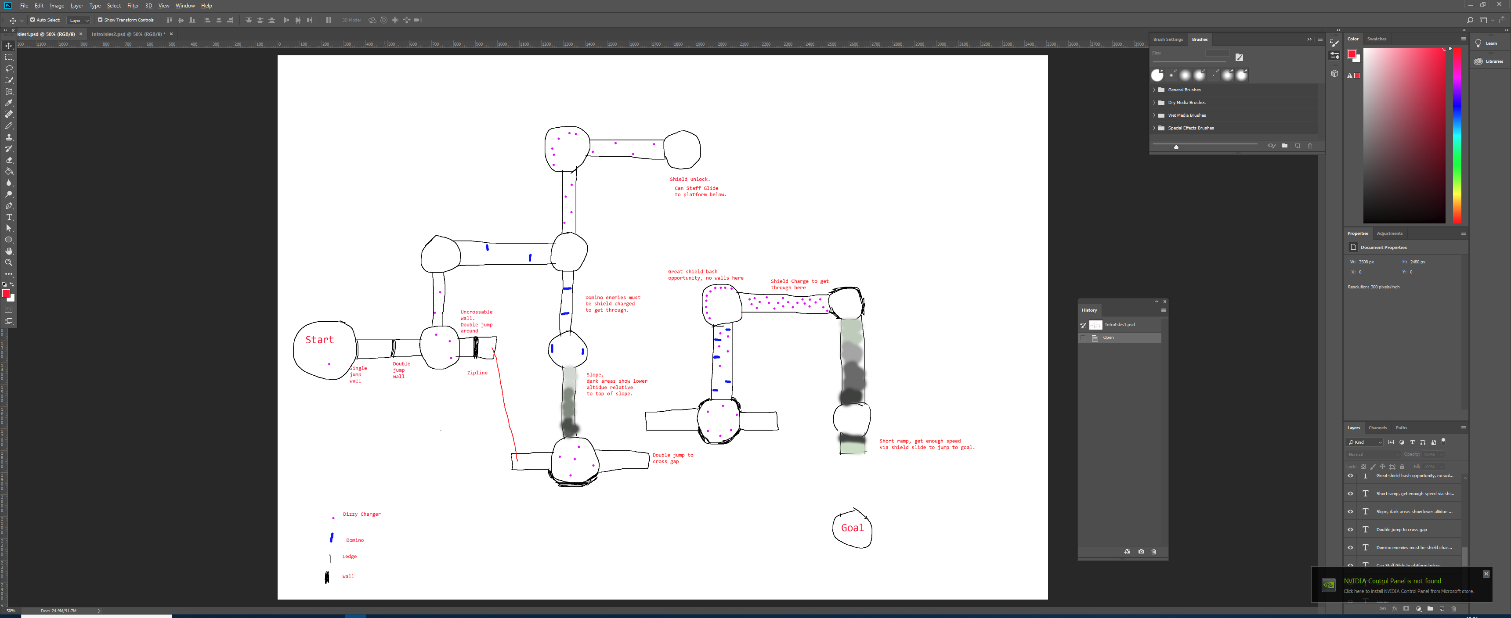

Figure 1 - The initial layout of Intro Isles.

**First Drafts:**

This was the first draft for the layout of Intro Isles. This tutorial stage introduced both the sword and the shield to the players, with skill gates for double jumps, shield charges and the shield slide, along with the dizzy charger and the domino enemies. Two shortcuts involving later techniques exist, using the red zipline with the scythe, and the staff hover to get to a faraway platform.

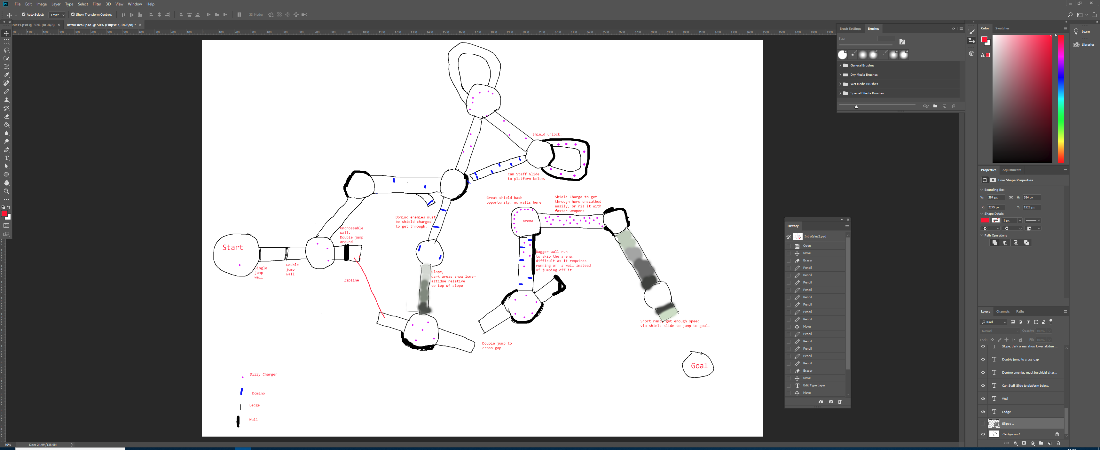

Figure 2 - The redesign after reconsideration.

**Second Draft:**

The second draft moved many of the islands around, to make the 90 degree turns less sharp, and more manageable at speed. Small developments made were the loops that make the tighter turns feasible, the return path after picking up the shield to help the player progress and the small ramp to make the shield slide more obvious. A new shortcut was made, by using the daggers to wall run on the outside of a wall and skip an arena, followed up with a grapple shot to land back on the platform. Some of these skips require other skips to be missed, like the staff glide preventing the zipline and dagger run being utilised, allowing the player to experiment for a faster path.

**Visuals Design and Aesthetics:**

In terms of visual design, the stage would consist of rulers, tin cans and cardboard, creating an art and craft feel. The use of a blue carpet and sandpaper would set up a beach theme to the level. As the first stage, it would receive the intro of the game, featuring the main character coming to life.

**Construction:**

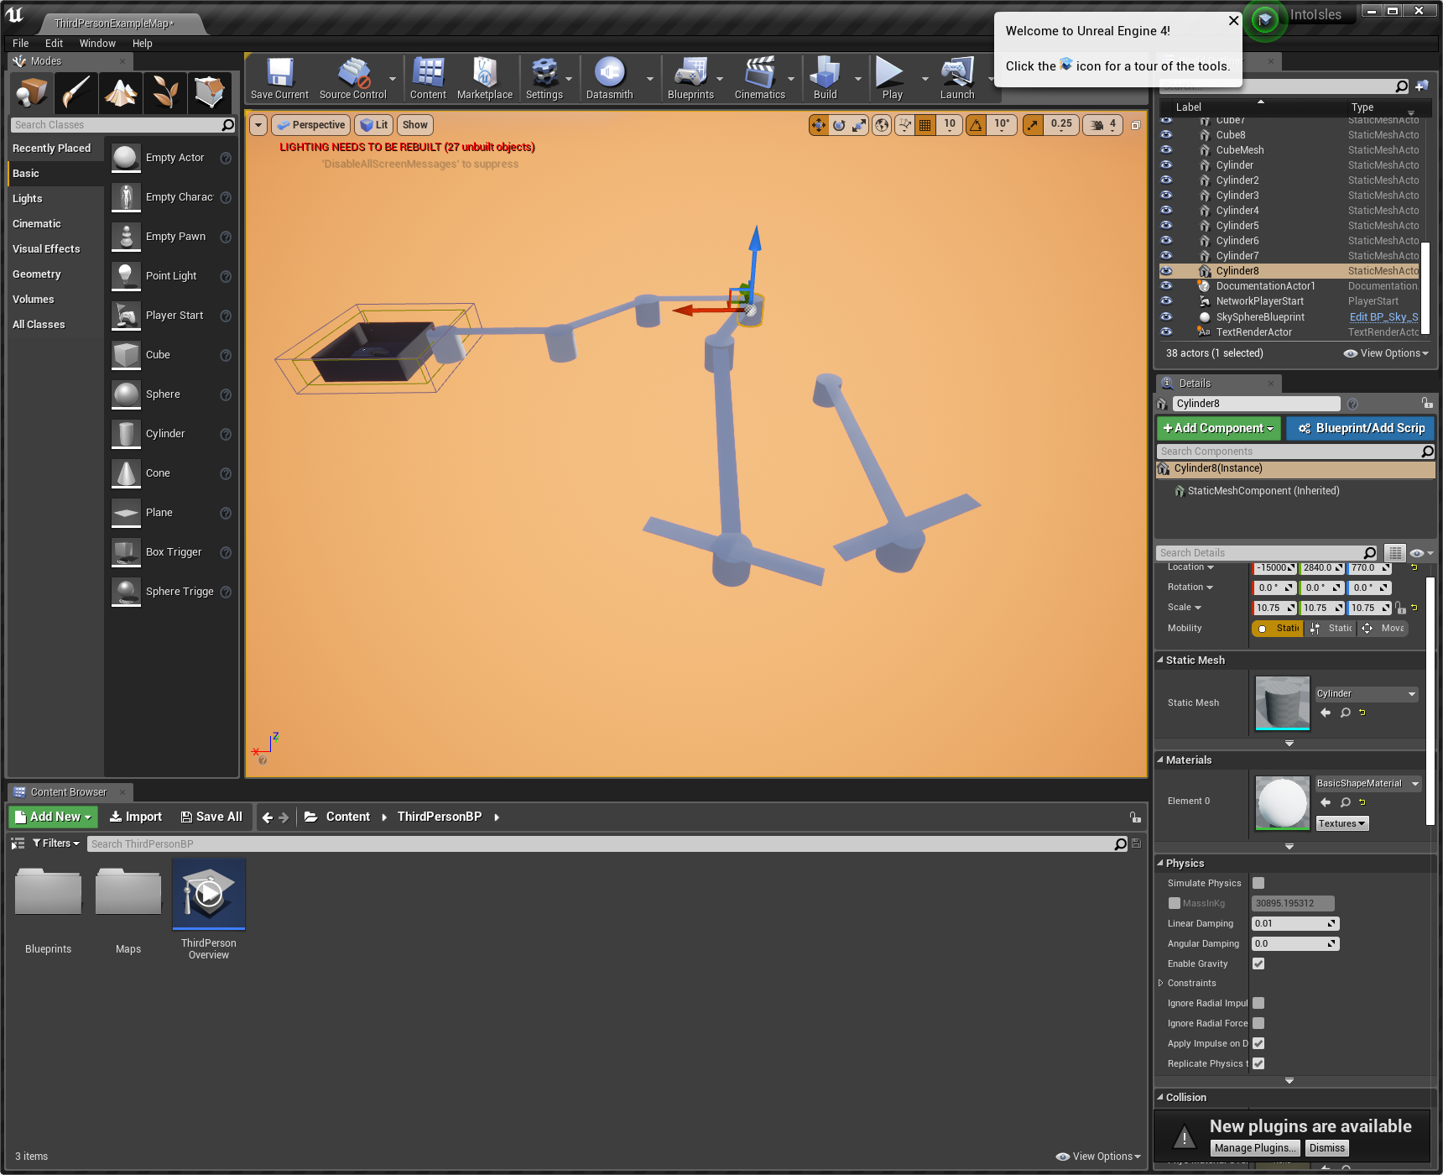

Figure 3 - The beginning of the white boxing. The sunset is used solely so that the level is more visible, but for a seaside level, it fits.

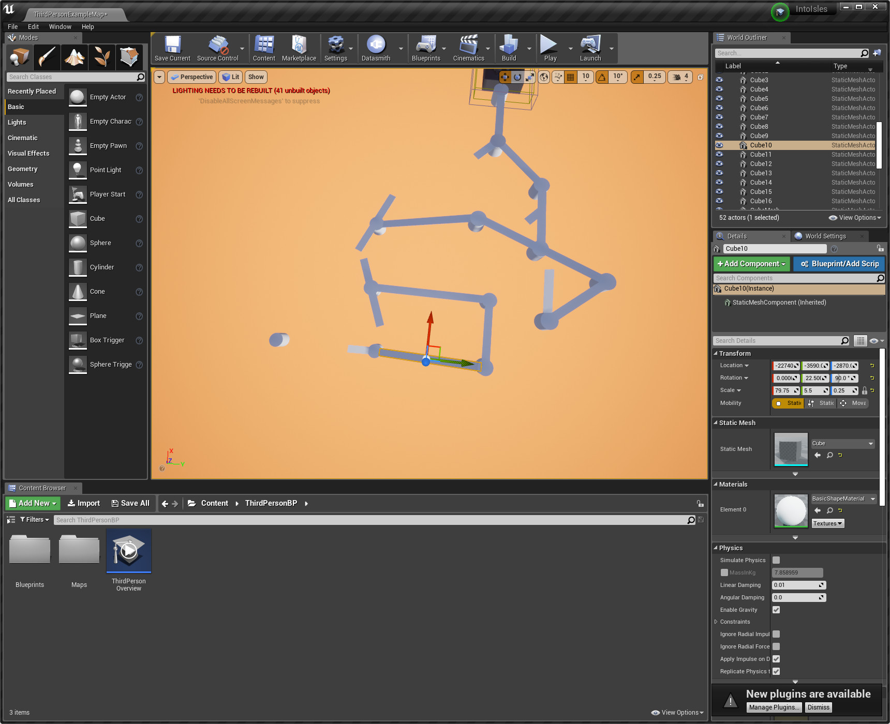

Figure 4 - All the main routes made.

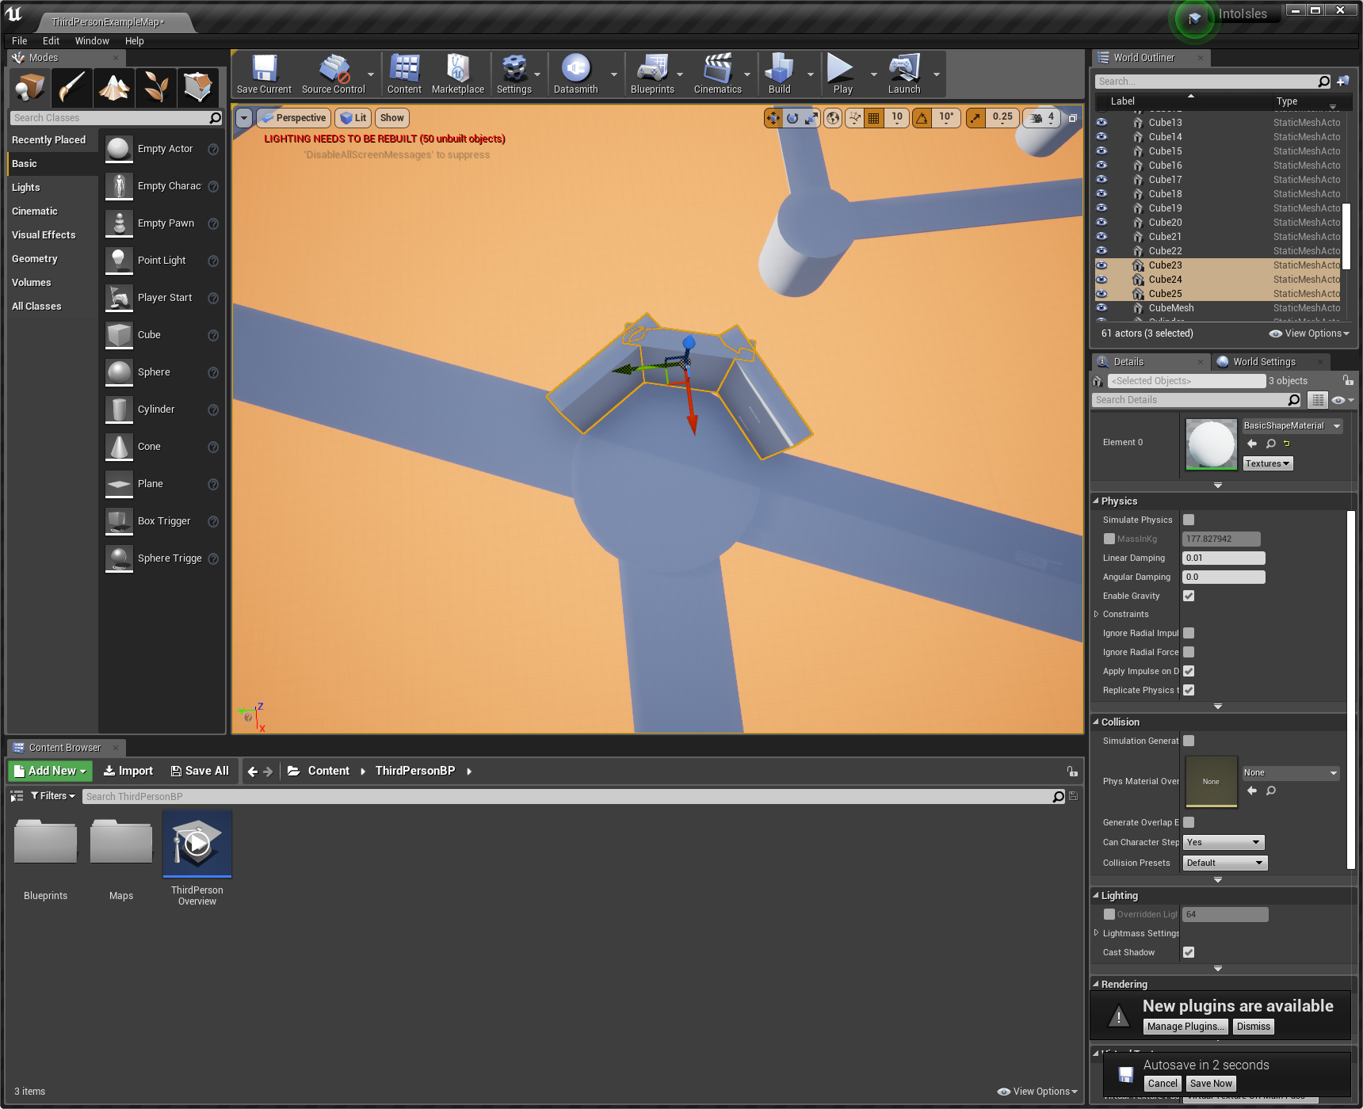

Figure 5 - Implementing the walls.

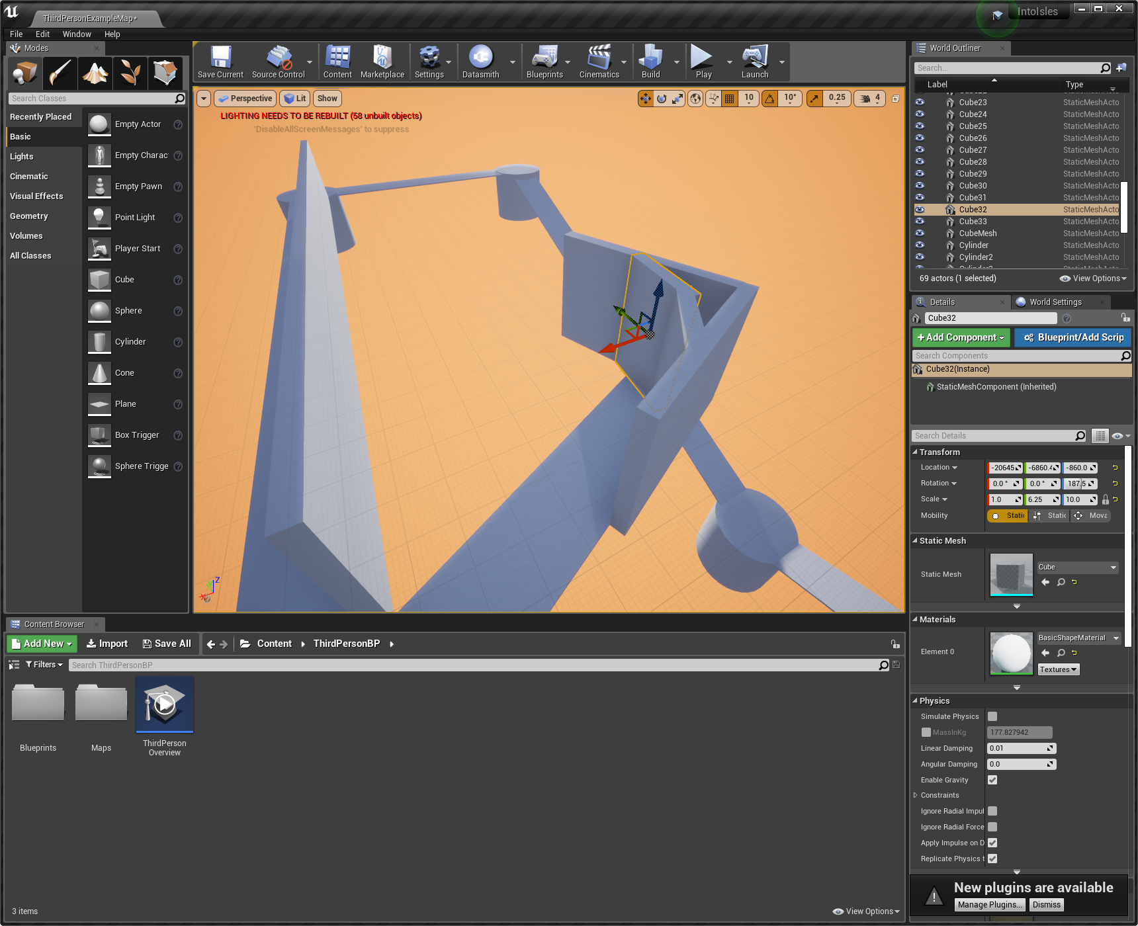

Figure 6 - The walls for the wall run shortcut.

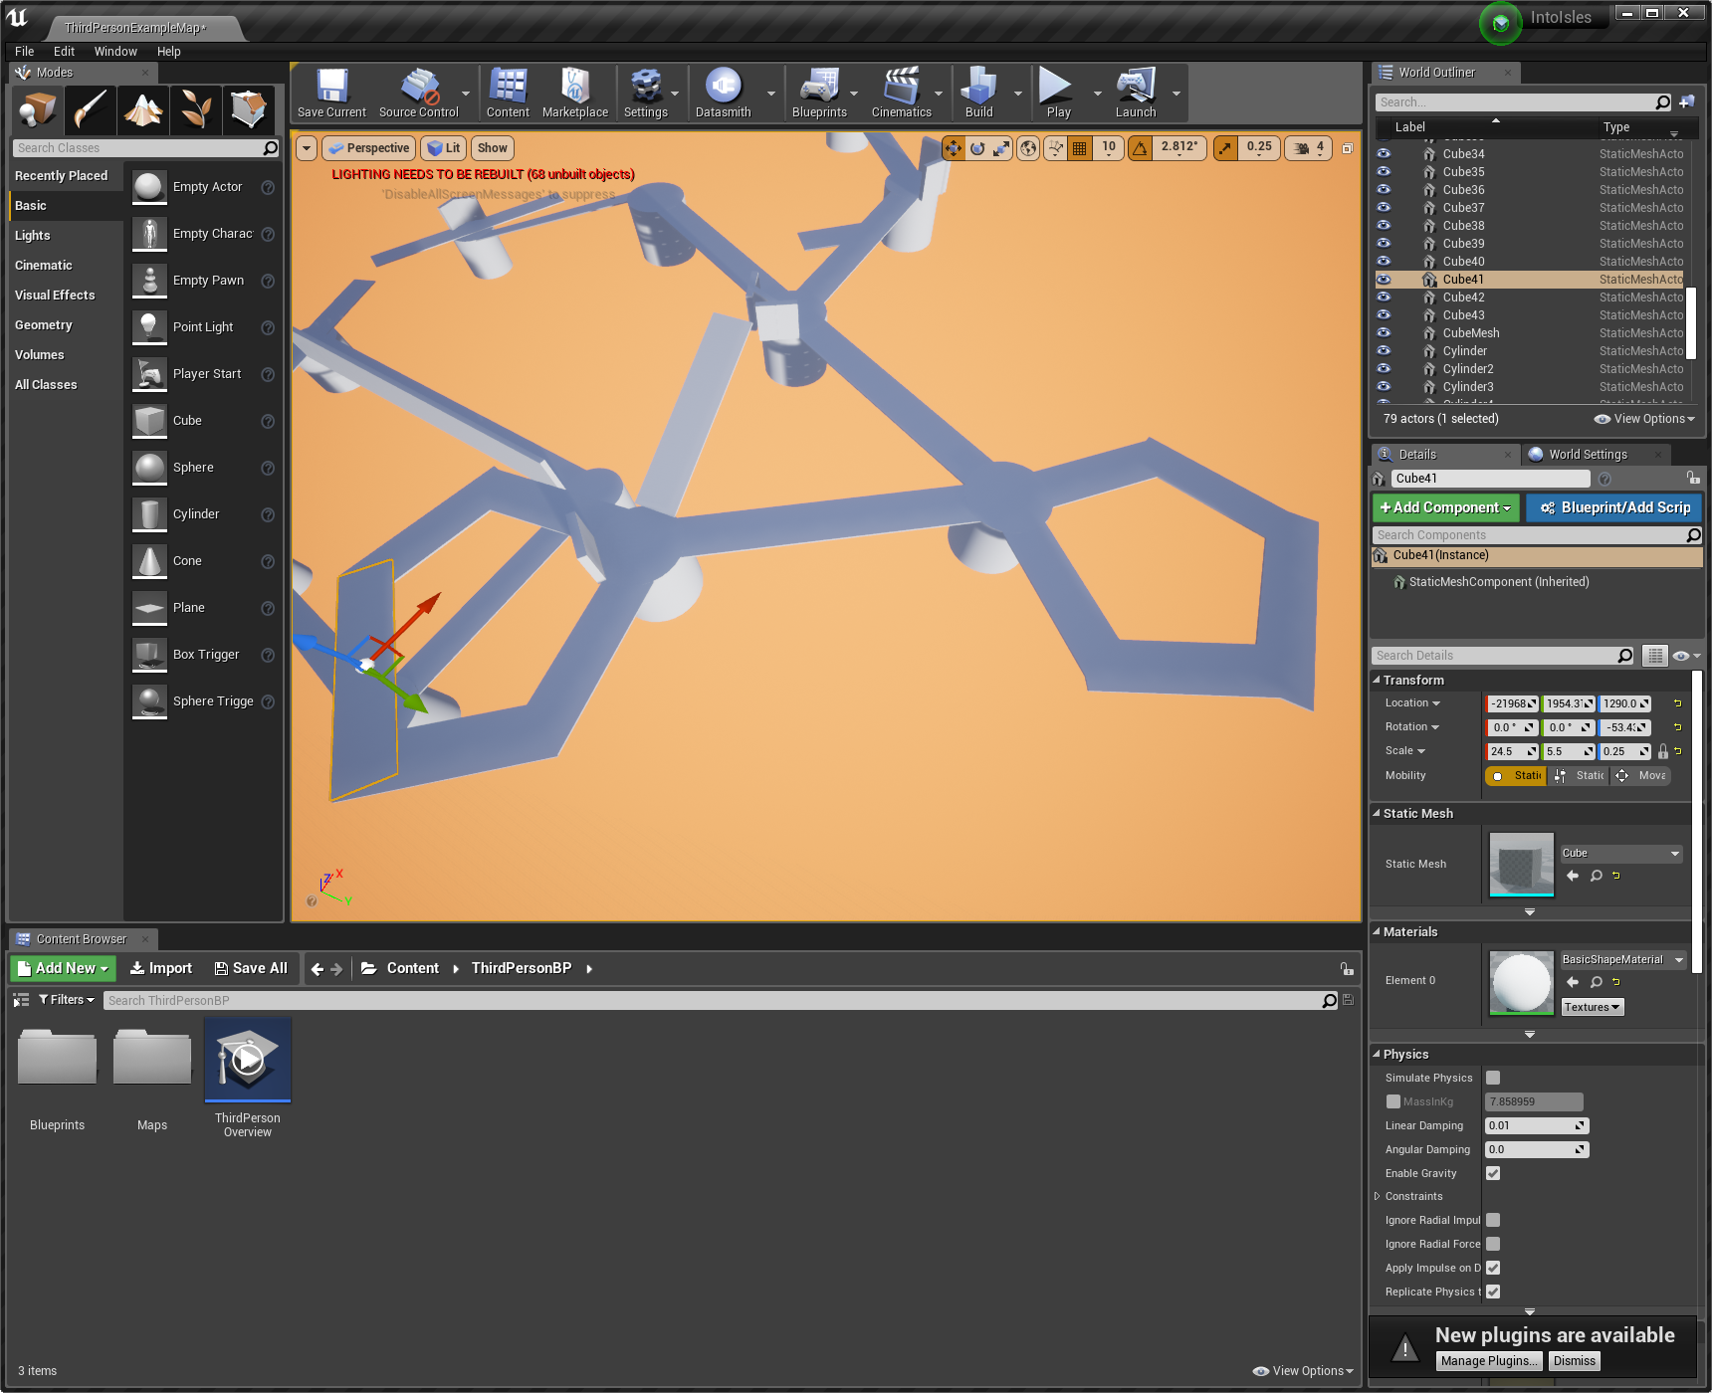

Figure 7 - The loops to make the tight turns.

**The Completed Layout:**

From here we can playtest the level, and determine is any corners are too sharp, and eliminate any jumps too hard to make. Once we are happy with the layout, we can focus on the lighting, textures, background details and enemy placements.

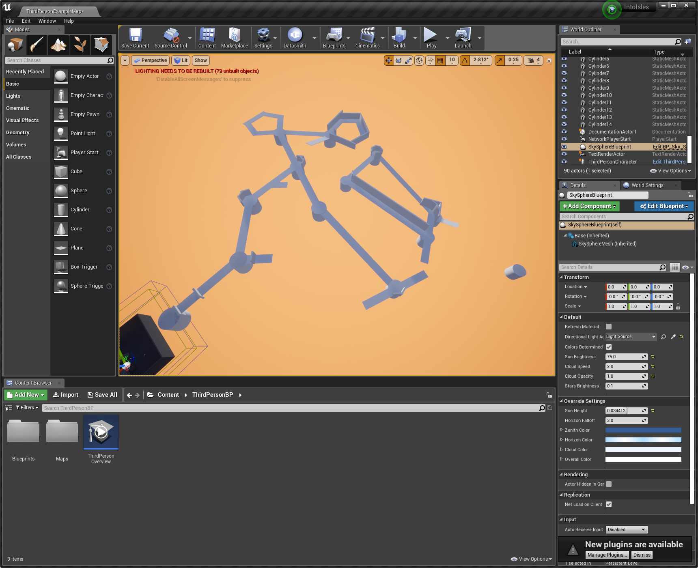

Figure 8 - The completed level layout